**Experiment 1**

**Aim:** To study and implement the terms in HTML

**Theory:**

INTRODUCTION TO HTML

HTML stands for Hyper Text Markup Language. It is the standard markup language for

creating Web pages. It describes the structure of a Web page. It consists of a series of

elements in the form of tags, attributes and its values. Elements of HTML tells the browser

how to display the content.

ELEMENTS:

The HTML element is everything from the start tag to the end tag:

<tagname> Content goes here...</tagname>

ATTRIBUTEs:

HTML attributes provide additional information about HTML elements. Attributes are always specified in the start tag.

Attributes usually come in name/value pairs like: name=”value”

HYPERLINK:

The href Attribute, <a> tag defines a hyperlink. The href attribute specifies the URL of the page the link goes to:

<a href =<https://vcet.edu.in/>> VCET </a>

FORMATTING :

Formatting elements were designed to display special types of text:

1. Bold - <b></b>
2. Paragraph: <p> This text is normal</p>
3. Italics - <i></i>
4. Underline - <u></u>
5. Subcript tag - <sub></sub>

**Code:**

<!DOCTYPE html>

<html>

<head>

<title>Page Title</title>

</head>

<body>

<header>

<h1>Page Heading</h1>

<nav>

<ul>

<li><a href="#">Home</a></li>

<li><a href="#">About</a></li>

<li><a href="#">Contact</a></li>

</ul>

</nav>

</header>

<main>

<article>

<h2>Article Heading</h2>

<p>Lorem ipsum dolor sit amet, consectetur adipiscing elit. Pellentesque vel venenatis felis. Fusce eu mollis orci.</p>

<section>

<h3>Section Heading</h3>

<p>Lorem ipsum dolor sit amet, consectetur adipiscing elit. Pellentesque vel venenatis felis. Fusce eu mollis orci.</p>

</section>

</article>

<aside>

<h3>Related</h3>

<ul>

<li><a href="#">Related link 1</a></li>

<li><a href="#">Related link 2</a></li>

<li><a href="#">Related link 3</a></li>

</ul>

</aside>

</main>

<footer>

<p> Footer</p>

</footer>

</body>

</html>

**Output:**

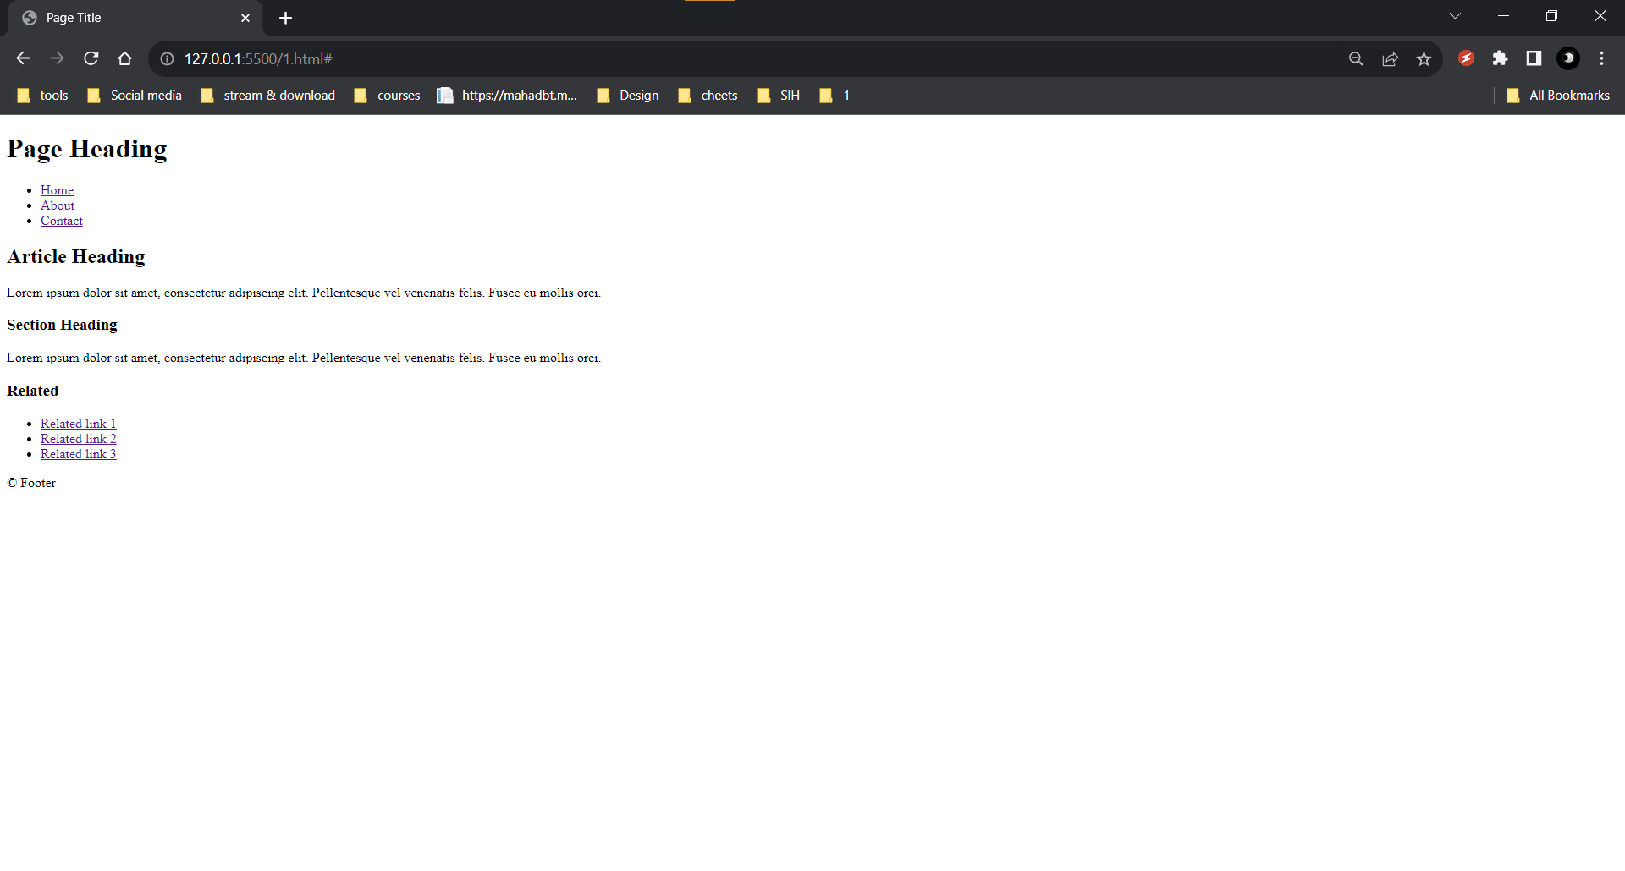

**Conclusion:**